**First level.**

Опис багів сайту <https://www.kmlvm.com.ua/>.

**№1.**

**Summary:** Error rendering the jquery.js library when loading the site on a mobile device.

**Description.**

**Preconditions:**Error playing the jquery.js library when loading the site on a mobile device iphone 6 ios 12.5.7.

**Steps to reproduce:**

**1.** Тhe site is open <https://www.kmlvm.com.ua/>.

**Extension result:** the site is open.

**Actual result:** a blocking window is displayed.

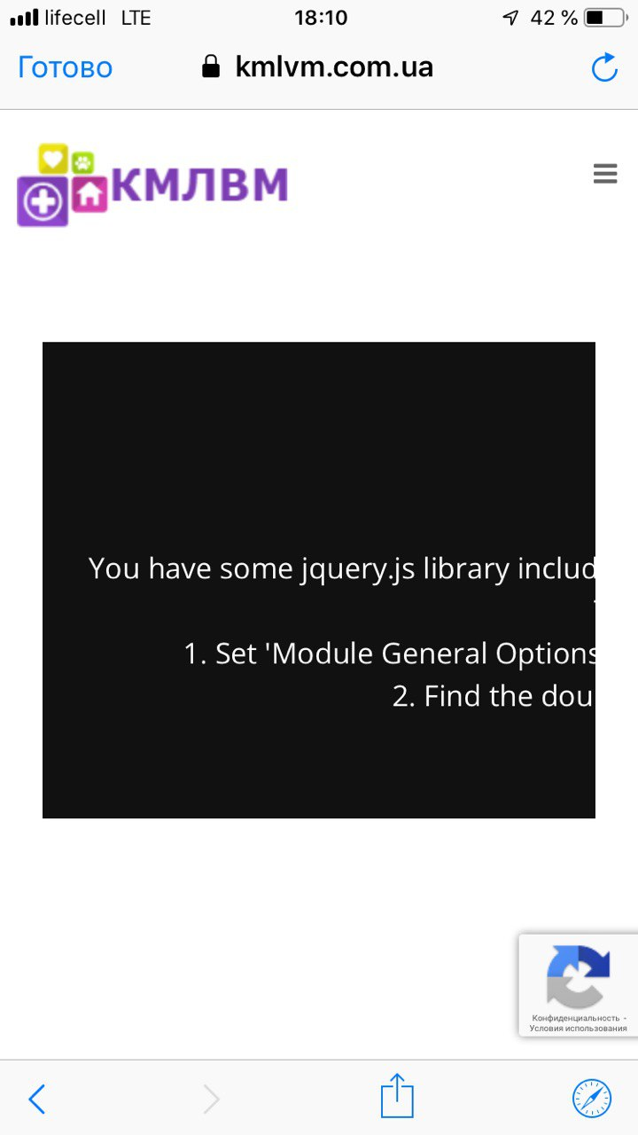

**Severity:** blocked.

**Priority:** high.

**№2.**

**Summary:** Window is displayed “Содержание не найдено” when click on the Facebook icon.

**Description.**

**Steps to reproduce:**

1. Тhe site is open <https://www.kmlvm.com.ua/>.
2. Click on the Facebook icon.

**Extension result:** Facebook account is opened.

**Actual result:** Window is displayed “Содержание не найдено”.

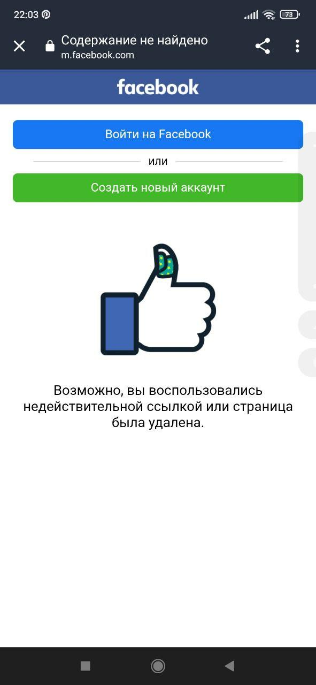

**Severity:** Tweak.

**Priority:** Medium.

**№3.**

**Summary:** Text goes beyond the form on the page Служба ветеринарної допомоги.

**Description.**

**Steps to reproduce:**

1. Тhe site is open <https://www.kmlvm.com.ua/>.
2. Go to the block Структура підприємства.
3. Drop-down window Служба ветеринарної допомоги is open.
4. Click on the button Детальніше.
5. Section Служба ветеринарної допомоги is open.
6. Go to the block Структурні підрозділи.
7. Тhe text goes beyond the form.

**Extension result:** The text is displayed within the form.

**Actual result:** Тhe text goes beyond the form.

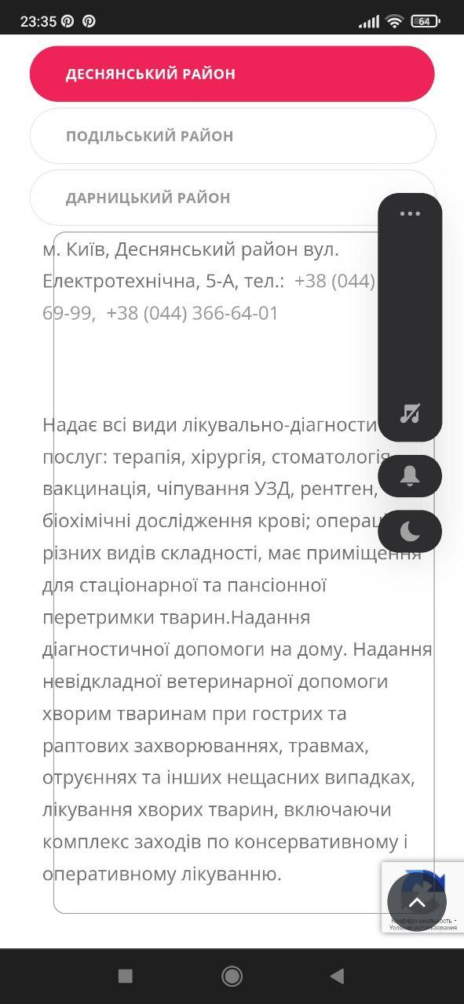

**Severity:** Trivial.

**Priority:** Lowly.

**№4.**

**Summary:** When selecting the Співробітники menu item, a window with a 404 error is displayed.

**Description.**

**Steps to reproduce:**

1. Тhe site is open <https://www.kmlvm.com.ua/>.
2. Go to the block Структура підприємства.
3. Drop-down window Служба Зоодопомога is open.
4. Click on the button Детальніше.
5. Section Служба Зоодопомога is open.
6. Сlick on the menu item Співробітники.

**Extension result:** Тhe accordion menu item Співробітникиis open

**Actual result:** Window with a 404 error is displayed.

**Severity:** Major.

**Priority:** Medium.

**№5.**

**Summary:** menu items are not displayed correctly when selecting the landscape orientation of the section screen Служба Зоодопомога

**Description.**

**Steps to reproduce:**

1. Тhe site is open <https://www.kmlvm.com.ua/>.
2. Go to the block Структура підприємства.
3. Drop-down window Служба Зоодопомога is open.
4. Click on the button Детальніше.
5. Section Служба Зоодопомога is open.
6. Тhe screen of the mobile device has a landscape orientation.

**Extension result:** Мenu items are displayed correctly.

**Actual result:** Мenu items are not displayed correctly.

**(місце для скріншота)**

**Severity:** Tweak.

**Priority:**Medium.

**Другий рівень.**

**Третій рівень.**

Чек-ліст перевірок мобільного додатку Дія.

USABILITY TESTING:

1. Checks the alignment of all fields.
2. Testing the correct display of elements.
3. Checking for errors in the text.
4. Checking the links.
5. Testing animations and transitions.

FUNCTIONAL TESTING:

1. Check if the program is installed and updated correctly.
2. Launch and display the Splash Screen.
3. Testing pop-up and push notifications.
4. Checking the functionality: registration, authorization, navigation.
5. Work in the background.

STRESS TESTS:

1. The load on the central processor.
2. Check the operation in conditions of memory shortage.
3. Check the impact on the battery.
4. Checking the network bandwidth.

PERFORMANCE TESTING:

1. Testing the loading time.
2. Check the speed of request processing.
3. Checking data caching.
4. Measurement of resource consumption.